LEDMatrix_22 Manual

Table of Contents

Overview 3

Types of LED configurations 3

Single Matrix 3

Tile Matrix 4

Multiplexing with Multiple-controllers (_new_) 4

Using multiple LED Strips together but not as a matrix or panel? 4

Compatibility with SmartMatrix and its various library combinations 4

Limitations in this library version 4

Getting Started 5

Other libraries and Documentation 5

Set up Steps 6

Tiles a.k.a. Blocks - Understanding led strip flow, zigzagging, blocks and tiles 6

Configuration _22.h (located in the Library folder) 7

Section 1: Required matrix array definitions 8

Section 2: #define HAS_BLOCKS 8

Section 3: #define HAS_EXTENDER 9

Your Sketch and Setup() 9

Setup() 9

FastLED.addLeds() 9

#if HAS_EXTENDER – use this call instead 10

LEDMatrix Functions 11

**The previous version of LEDMatrix include descriptions of the basic graphics draw routines (circle, square, triangle, etc.)** 11

These are all still supported in LEDMatrix_22, with a select few renamed to reflect Adafruit_GFX naming conventions. See: Other libraries and Documentation above 11

Several Important Changes from FastLED 11

NEW Functions in LEDMatrix_22 11

General Functions 11

Graphics General Functions 12

Display “Block save” and “Block restore” Functions 12

24 bit color Bitmap Functions (CRGB color = 3 bytes RGB) 12

Loading Bitmaps 12

24 bit color Sprite Functions (CRGB color = 3 bytes RGB) 13

Multiple LED strips not than in a Matrix 14

Understanding the LED Extender, multiplexing, and limitations of serial strip LEDs 15

Files in the LEDMatrix_22 Library 15

New Features 15

24 bit full color bitmap images (sprites) 15

Using variables instead of #defines 16

#define compiler errors 16

Side stepping this problem 16

Creating a Lookup Table 17

XYTable_LookUp Code header file 17

Other Look up Table apps 18

Irregular LED Arrays 18

Irregular Array Example 18

DEBUGGING REPORT - sent to the serial terminal 20

Sample Report 20

Advanced Topics 21

Access Directly to the m_LED[] array in the FastLED library 21

FastLED #defined constants – more flexible programming 21

List of all definitions describing the matrix panel 22

Memory mapping in LEDMatrix_22 22

Dr Oldies LED Extender 24

LED Extender Enabled Functions 24

Array Memory Use 24

Section 3a: #define HAS_EXTENDER 25

Section 3b: LED Extender pin definitions in the Extender section 25

Understanding the configuration header sections in combination 26

Errors and Possible Fixes 27

Redefined PROGMEM Error 27

Report_Generator compile errors 27

List of Functions 28

FastLED function list (partial) 30

FastLED.h 30

Controller.h 31

LEDMatrix_22 Manual

# Overview

The LEDMatrix_22 library is a medium weight, two-dimensional graphics library for LED matricies/arrays using FastLED. This is an update and enhancement of previous LEDMatrix libraries. In addition to drawing shapes, and text, this library expands image and animation handling to 24 bit color. Larger displays can be formed using tiles of LED strip/panels - to build one big matrix. New and enhanced feature include:

* 2-wire LEDs: APA102, Adafruit's DotStar, SK9822, HD1701, LPD8806, SM16716, WS2801.
* 1-wire NEOPIXEL LED strips and arrays (WS2812, etc.).  <http://fastled.io/docs/3.1/>
* 24 bit color image and basic sprite display (no edge detection).
* Block save/restore to restore backgrounds.
* Transparent sprite drawing. (No boundary detection)
* Text, image, and sprite rotation in 90 deg increments.
* Option to read a XYTable_LookUp.h to replace slower, complex coordinate calculations.
* An Arduino sketch utility to create the lookup table is included.
  + The lookup table option allows for irregularly shaped LED physical layouts.
* A report generator to comfirm proper LED array mapping configuration.
* Method names now use Adafruit_GFX naming (for similar methods).
* 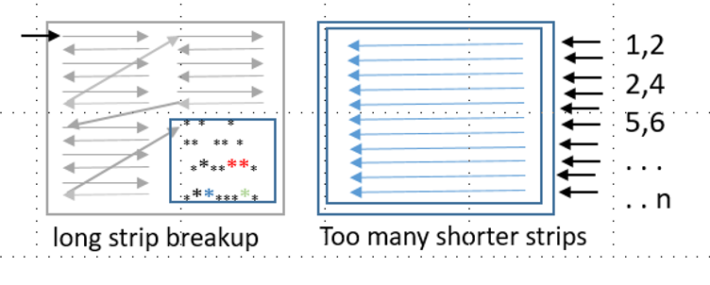Along with a soon-to-be-release Dr Oldies LED Extender shields for 2-wire LED strips can be wired in multiple Banks to reduce LED strip length. The extender:
  + Eliminates LED "sparkle" and flashing (a frustrating problem with 2-wire LED types) by reducing the number of LEDS needed in series.
  + With proper power supplies, and wiring, the Extender can support up to at least 256 LEDs per strip. That's 64,000 LEDs! A 32 bit MCU such as the Teensy 4.0/4.1 is required.
  + Multiplexes controller wiring, reducing pin count 1-wire or 2-wire LED strips. Up to 16 LED strips/panels with only 8 wires! (4 for 2 DATA + 2 CLOCK pins, and up to 4 more "enable" pins to switch between Banks of LED strips.
  + Voltage step up from 3.3v to 5v.
  + Isolates the MCU from the LED wiring.

## Types of LED configurations

### Single Matrix

In this arrangement, one long led strip is cut into multiple rows to create an x,y array. As with previous LEDMatrix versions, the strips can be arranged into rows a zigzag, or left-2-right/right-2-left patterns. In this configuration you are limited to the length of the strip before sparkles/breakup occurs. SPI pins can be used to meet the demand of refreshing long data strings. This approach uses one FastLED Controller.

### Tile Matrix

Tiling (also called blocks) breaks the one long LED strip into smaller tiles. Popular 8x8 led panels are an example of this. The 8x8 panels can be strung together. LEDMatrix_22 can handle any arragement of these in normal or zizag LEDS in tiles, and normal or zizag tiles in the larger matrix panel. This approach uses one FastLED Controller.

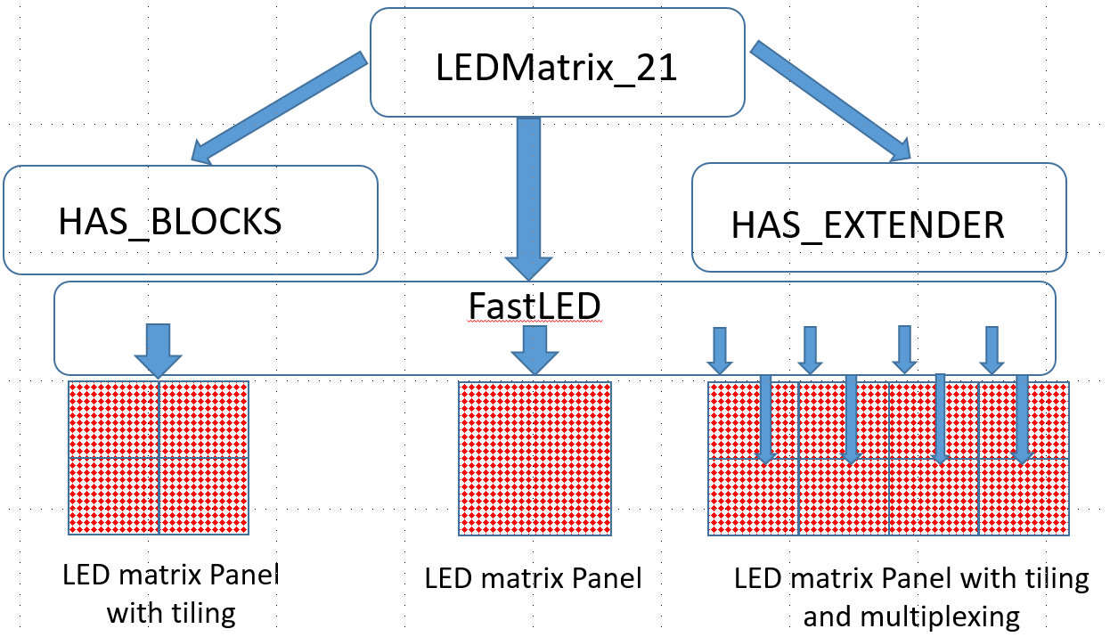

Figure 1 LEDMatrix modules for simple and tiled arrays as well as extending to large arrays and higher data/frame rates.

### Multiplexing with Multiple-controllers (_new_)

LEDMatrix_22 supports a small shield PCB and FastLED's multiple Controllers to drive shorter strips or tiles rather than one long strip. For example, to drive a 32x32 matrix of 1024 LEDs with one long string, data send rates, brightness, and frames-per-second (fps) to avoid color breakdown as to be unusable.

Now, using the LEDExtender we can break up the 32x32 matrix and insert a second DATA/CLOCK line for LEDs 512-1024. No more sparkle even with higher data/brightness/fps rates. Additing additional data lines for 256, 128, or 64 LED segments allows even high data rates.

### Using multiple LED Strips together but not as a matrix or panel?

Check out the LEDStrips_22 library. This library is designed to use the LEDExtender shields to control up to 16 LED strips with 8 controller pins (the same as above).

### Compatibility with SmartMatrix and its various library combinations

LEDMatrix_22 is designed as a medium weight library, with just enough features to support your project. Beyond FastLED (and the LED types FasyLED supports), this library is not intended to be combined or layered with other libraries.

### Limitations in this library version

SmartMatrix has transitioned into a software + hardware solution primarily for HUB75 LED panels. LEDMatrix_22 currently does not support SmartMatrix or HUB75 hardware.

# Getting Started

Configuring LEDMatrix_22 for 2 simple project with an array that is one long led strip (even if it is assembled in a number of row to make a matrix. Set the led type, the number of leds horizontal and vertical, and the data/clock pins at the top of Configuration_22.h. Don’t forget to set HAS_BLOCKS and HAS_EXTENDER as false.

Configuring LEDMatrix_22 for a project using 4 x 4 or 8 x 8 commercials LED panels, multiple strips, or irregular shaped layout can be a bit confusing. Make sure to read through this manual or the wiki before you start. I added many comments in the headers and the example code that should help.

## Other libraries and Documentation

The previous version of LEDMatrix include descriptions of the basic graphics draw routines (circle, square, triangle, etc.) these are all still supported in LEDMatrix_22, with a select few renamed to reflect Adafruit_GFX naming conventions.

**LEDMatrix** by VikingGod [Jürgen Skrotzky] is at:

<https://github.com/Jorgen-VikingGod/LEDMatrix> with additional descriptions here: <https://jorgen-vikinggod.github.io/LEDMatrix>

There is also a wiki for an even earlier version of LEDMatrix by Aaron Liddiment at:

<https://github.com/AaronLiddiment/LEDMatrix/wiki>

**FastLED** by Garcia is a well liked interface for all the leds supported by LEDMatrix_22:

**FastLED** Documentation. While this is for version 3.1, it is the most complete description of FastLED is here:

<http://fastled.io/docs/3.1/>

There is also a **FastLED Wiki** here: <https://github.com/FastLED/FastLED/wiki>

How to use Excel to Animate LEDs! Arduino + WS2812 LEDs by Kevin Darrah: <https://www.youtube.com/watch?v=A_S3LAUQHwU>

Sprites – here are a few sprites to play with:

<https://spritedatabase.net/download>

# Set up Steps

Before setting the definitions in the configuration_22.h file, let’s review how large led matrices are laid out. This is the most confusing part of using LEDMatrix. Look at the figure below as you decide on your led panel layout.

The most popular leds are now serial leds i.e. wiring goes from led #1 then to led #2, and so on, like Christmas light strings. This compares to older “RGB” leds that worked using a wiring matrix of anode and cathode wires. LEDMatrix_22 support both 1-wire and 2-wire led strips. 1-wire uses 1 data lead and timing cycles to transfer data to the led string. 2-wire led strips use a data and a clock to transfer data. They both have advantages and disadvantages that are not discussed here.

So a led matrix panel is made up one long led strip. This include a simple 8x8 array with 64 leds or a 32x32 led matrix with a whopping 1024 leds. The led strip can be string out in one continuous zigzag pattern (even rows one direction, odd the opposite), either horizontally or vertically. Alternatively, the string can be cut into equal lengths and every row running in the same direction. Finally, the first led of the string can be in any of the 4 corners of the panel. L

**LEDMatrix can be configured for any of these. For these “simple” layouts, you will use Section 1 of the configuration _22.h file.**

## Tiles a.k.a. Blocks - Understanding led strip flow, zigzagging, blocks and tiles

Purchased long led strips are difficult to lay out and glue to a surface. Then often don’t look very professional. An alternative if to buy smaller 8x8 led panels. For example, Dotstar or Nedpixel panels from Adafruit. Placing these panels next to each other into a larger 16x16, 8x32 or other layout works great. A second approach is to buy or make your own panels, and add discrete leds. Services like jlcpcb.com will do both at a reasonable price. Previous versions of LEDMatrix called these tiles “blocks” in configuration definitions so I will use tiles and blocks interchangeably.

At 1st look, all the definitions seem confusing, but in LEDMatrix_22 these are separated into three groups, with detailed explanations of each parameter. Here are the definition with code comments removed for clarity.

The configuration header file is broken into 3 sections:

Section 1: Required matrix array definitions

Section 2: #define HAS_BLOCKS

Section 3: #define HAS_EXTENDER (for 2-wire LEDS only)

Setting the following defines to true/false will enable/disable these sections:

*#define HAS_BLOCKS true/false //Section #2*

*#define HAS_EXTENDER true/false //Section #3*

### Configuration _22.h (located in the Library folder)

Configuring this library and FastLED requires a number of parameters and #defines. Configure your LED array in configuration_22.h located in the library folder. This way you can reuse your configuration file(s) across all your sketches. Consider renaming your project configurations (or changing the #include "configuration_22.h" in the library folder.

#### Section 1: Required matrix array definitions

Section #1 of the configuration_22.h file contains the configuration for the over-all matrix panel. If your project is a matrix make up of one long string of leds, this is the only configuration you will need to do. Set the #defines in section #2 and #3 to *false.*

#### Section 2: #define HAS_BLOCKS

Section #2 of the configuration_22.h file allows you to enable/disable blocks in your matrix with the HAS_BLOCKS true/false define. In the non-block example sketches, this section has been delete for simplicity. The figure below shows possible tile/block arrangements. If you look at each tile as small matrix panel, then all the definitions in Section #1 make sense at the top of section #2, (row, column, zigzag, etc).

The bottom part of Section #2 defines how tiles/blocks are arranged in the overall matrix panel. If you look at tiles as single virtual leds in the panel, then tiling definitions fall into place. L-2-R, R-2-L, top down, bottom up, and zigzagging of the virtual leds.

#### Section 3: #define HAS_EXTENDER

Section #3 of the configuration_22.h file applies to the Dr Oldies LED Extender for 2-wire LEDs. This will be detailed later. For example configurations not using the Extender, Section #3 has been left out for simplicity.

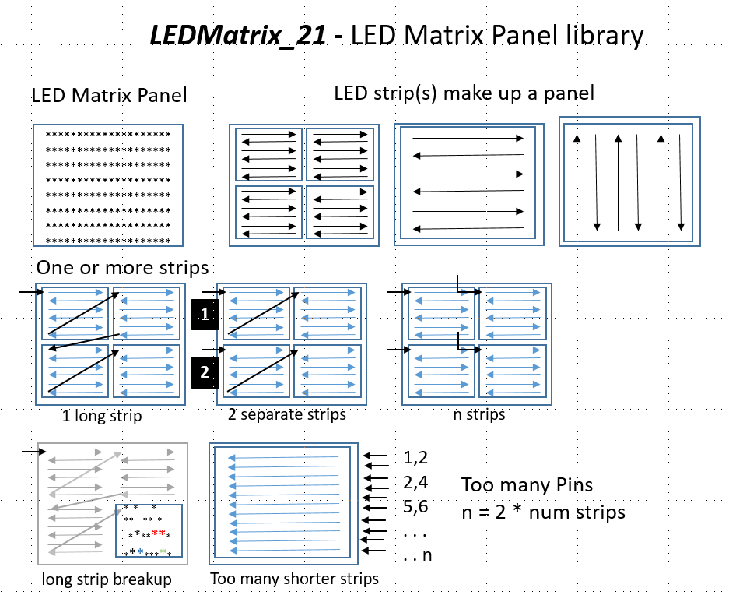

Figure 2 various ways to organize LED matrix panels

# Configuration _22.h (located in the Library folder)

Configuring this library and FastLED requires a number of parameters and #defines. Configure your LED array in configuration_22.h located in the library folder. This way you can reuse your configuration file(s) across all your sketches. Consider renaming your project configurations (or changing the #include "configuration_22.h" in the library folder.

## Section 1: Required matrix array definitions

Figure 3 section1: Required matrix array definitions

< Teensy 4.0 and 4.1 are the preferred MCUs, but other 32 bit MCUs are fine. UNO and other 8 bit MCUs are too slow.



< Find these parameters in FastLED Documentation

SPI speed applies even if not using SPI pins.

< Speed, fps, and brightness together to limit the quality of the led display

Parameters of simple or total MATRIX PANEL

< Size of matrix in LEDs.

< Direction of led strips horiz or vertical

< Direction of 1st led row/column

< Total leds (calculated)

**Comments**

## Section 2: #define HAS_BLOCKS

If you’re led matrix is a simple strip of leds (running in any direction), you can ignore this section and the header definitions. Set HAS_BLOCKS false, or use an example configuration_22.h without this section.

Figure 4 Section 2: #define HAS_BLOCKS

< For tiles MUST define as true

< The size of tiles in leds

< Number of tiles in the matrix panel

< How leds flow in each tile

< Direction of 1st led row/column



**Comments**

## Section 3: #define HAS_EXTENDER

Section #3 of the configuration_22.h file applies to the Dr Oldies LED Extender. This will be detailed later. For example configurations not using the Extender, Section #3 has been left out for simplicity.

If you are not using the LED Extender Shields, ignore this section and the header definitions. Set HAS_EXTENDER false, or use an example configuration_22.h without this section.

2 wire LEDs are limited in the number of LEDs that can be addressed on each strip. Too many LEDEs and they begin to blink and flash erratically. Reducing the send rate, fps, or brightness helps only a little. These Dr Oldies extender boards and Teensy shields increase the number of LED strips that can be used with a reduced pin count. Each extender uses 4 (2 data/2 clock pins) to address 4 LED strips. Up to 4 extenders can be address with the SAME 4 PINS, plus 1 "enable" pin for each of the 4 extender boards - 16 strips with only 8 pins! This dramatically increases the total number of addressable LEDs!

Definition Descriptions

*#define HAS_EXTENDER true // Dr Oldies LED Extender shields. If there are no shields, ignore this section.*

*#define NUM_BANKS 4 //1 to 4 extender "banks" |*

*#define STRIPS_PER_BANK 4 //1 or more but 4 strips per Bank is the most efficient use of the hardware*

*#define NUM_STRIPS STRIPS_PER_BANK * NUM_BANKS //total number of strips used*

---------------- Choose pins to enable each bank -------------------

Define as many as the number of Banks.

**NOTE: Any of the Teensy boards can be positioned in 2 ways on the shield.

Alignment 1. Align the Teensy GROUND pin (next to the 0 pin) with the LARGE "G" on the shield.

Alignment 2. Align the Teensy GROUND pin with the SMALL "G" on the shield.

*//Alignment 1 Enable Pins*

*#define BANK_PIN_0 5*

*#define BANK_PIN_1 6*

*#define BANK_PIN_2 7*

*#define BANK_PIN_3 8*

*/\**

*//Alignment 2 Enable Pins*

*#define BANK_PIN_0 18*

*#define BANK_PIN_1 19*

*#define BANK_PIN_2 20*

*#define BANK_PIN_3 21*

*\*/*

---------choose DATA and CLOCK pins in the bank (all banks use the same pins)---------

The same data/clock pins are used for all Banks, and made active by the BANK_PIN above.

*//All 4 are required regardless of 2, 3, or 4 physical strips per Bank.*

*//Alignment 1 data/clock Pins*

*#define DATA_1 1*

*#define CLOCK_1 2*

*#define DATA_2 3*

*#define CLOCK_2 4*

*/\**

*//Alignment 2 data/clock Pins*

*#define DATA_1 14*

*#define CLOCK_1 15*

*#define DATA_2 16*

*#define CLOCK_2 17*

*\*/*

================================= end of user definitions ==============================

Final note: The values slice and dice the FastLED array up into a Bank size then into strips in each Bank Number of LEDS IN EACH BANK - this is the value used in FastLEDS.addleds() <<<<<<<<<<<<<<<<<<<< since FastLEDS only "sees" 1 Bank of led strips, and thinks its the SAME strips even when we are switching banks.

# Your Sketch and setup()

After configuring your hardware, next create the led memory arrays in your sketch. At the top of you sketch *before* setup() add the following. First include the LEDMatrix_22 library. Next create the matrix panel array in memory. Unfortunately, the calling format when using Dr. Oldies Extender configuration is different than without. Choose the call that appies to your project.

**Allow the #if statement to choose the calling format or delete the un-needed code.**

*#include <LEDMatrix_22.h> //includes FastLED.h*

*//------------------- create the total matrix panel array -------------------*

*#if HAS_EXTENDER || HAS_BLOCKS*

*cLEDMatrix<MATRIX_TILE_WIDTH, MATRIX_TILE_HEIGHT, LEDS_IN_TILE, MATRIX_TILE_H_DIR,*

*MATRIX_TILE_V_DIR, TILES_IN_MATRIX> leds;*

*#else*

*cLEDMatrix<MATRIX_WIDTH_DIR, MATRIX_HEIGHT_DIR, MATRIX_TYPE> leds;*

*#endif*

Next configure FastLED.addLeds() and the Extender (if you are using the Extender hardware.

FastLED.addLeds() sets up the memory and drivers for all the internal functions. Please note that there are different calling formats for different CHIPSETs as listed below:

* LEDMatrix_22 uses a slightly different .addLeds() format then FastLED sketches.
* FastLED requires different .addLeds() format depending on the type of led (CHIPSET): 1-wirw, 2-wire, or Neopixels.
* I included 1 lengthy comment in each example sketch as needed to – just delete what you don’t need.
* setCorrection is optional. See the FastLED manual for more information.

**Here are a few FastLED.addLeds() examples:**

1. LEDs requiring DATA + CLOCK such as APA102. Also called 2-wire LEDs.

*FastLED.addLeds<CHIPSET, DATA, CLOCK, COLOR_ORDER, DATA_RATE_MHZ(SPI_MHZ)>(leds[0],*

*NUM_LEDS).setCorrection(CORRECTION);*

1. LEDs that have just a DATA pin; no CLOCK pin such as WS2812x. Also called 1-wire LEDs
2. If CHIPSET is NEOPIXEL, use this version. NOT Allowed with Teensyx MCUs

Use the format in c. below, and use the real led type name WS2811, WS2812, or SK6812.

*FastLED.addLeds<NEOPIXEL, DATA>(leds[0], NUM_LEDS);*

1. For all 1-wire LEDs use this format. NOT Allowed with Teensyx MCUs

Use the format in c. below.

*FastLED.addLeds<CHIPSET, DATA, COLOR_ORDER>(leds[0], NUM_LEDS).setCorrection(CORRECTION);*

1. Teensy MCU boards for 1-wire LEDs requires it’s own format.

Teensy MCU requires a NUM_STRIPS parameter at the beginning of the .addLeds()

because FastLED requires the number of strips (NUM_STRIPS) as the 1st .addLeds() parameter.

In Configuration_21.h: #define (FASTLED_TEENSY4) or #define (FASTLED_TEENSY3).

NUM_STRIPS is usually 1 unless you are doing parallel led strips.

Note: NUM_STRIPS will already defined in configuration_21.h if HAS_EXTENDER is enabled.

*#define NUM_STRIPS 1 //only if not defined in configuration_21.h*

*FastLED.addLeds<NUM_STRIPS, CHIPSET, DATA, COLOR_ORDER>(leds[0], NUM_LEDS);*

*// ^ for TEENSY without NUM_STRIPS all leds on full white*

## #if HAS_EXTENDER – use this call instead

If you are using 2-wire leds (APA102 or similar) and the Dr. Oldies LED Strip Extenders, define HAS_EXTENDER as true in Configuration_22.h and configure the Extender section settings in this section.

This is the only call you need to complete setup of the matrix is this line of leds.ExtInit

*leds.ExtInit(NUM_LEDS, NUM_BANKS, NUM_STRIPS, BRIGHTNESS);*

# LEDMatrix Functions

### **The previous version of LEDMatrix include descriptions of the basic graphics draw routines (circle, square, triangle, etc.)**

### These are all still supported in LEDMatrix_22, with a select few renamed to reflect Adafruit_GFX naming conventions. See: Other libraries and Documentation above

## Several Important Changes in LEDMatrix_22 from FastLED

To handle the new multiplexing Banking features of this library several new functions replace previous FastLED functions. These actually streamline your code, reducing the mixing of LEDMatrix’s led.xxx() and FastLED.xxx() function calls.

**All functions listed are prefaced with as the default with “leds.” as in leds.LEDshow() format.**

Of course, you can create the leds class with any name you want. In this case the example function call will be: [your class name].LEDshow()

|  |  |  |
| --- | --- | --- |
| **LEDMatrix_22** | **FastLED** | **Comments** |
| leds.ExtInit(numLeds, numBanks,  numStrips, brightness) | n/a | Use with Dr Oldies LED Extender Shields in setup(). This function initializes the controllers for the LED Extender Shields. |
| leds.LEDshow(), | FastLED.show() | Refreshes display w/ and w/o Extender banking |
| leds.LEDShow(brightness) |  | Display with a local brightness |
| leds.SetBrightness(brightness) | No global brightness for multiple controllers | Sets global brightness w and w/o banking |
| leds.fillScreen(color) | FastLED.fillScreen(color) | Fills the display w/ and w/o banking |

## NEW Functions in LEDMatrix_22

### General Functions

|  |  |
| --- | --- |
| **New to LEDMatrix_22** | **Comments** |
| clear() | Clears to black AND displays in 1 step |
| showColor(color); |  |
| setBrightness(uint8_t bght); |  |
| fadeAll(uvalue); | This was in the Cylon() example in FastLED. It is a useful graphics feature and has been added. |
| drawPixel(x, y, color) | Draw pixel in previous libraries did not properly rotate the drawing functions. |

### Graphics General Functions

|  |  |
| --- | --- |
| **New to LEDMatrix_22** | **Comments** |
| CRGB getPixel(x, y); | Return pixel color in CRGB format |
| drawTriangle(x0, y0, x1, y1, x2, y2, color); | Color triangle |
| drawFilledTriangle(x0, y0, x1, y1, x2, y2, color); | Filled color triangle |
| drawRoundRect(x, y, w, h, r,  color); | Rectangle with rounded corners |
| drawFillRoundRect(x, y, w, h, r, color); | Filled rectangle with rounded corners |

### Display “Block save” and “Block restore” Functions

**24 bit full-color (CRGB) Block functions are new. These are blocks of the diplay that can be saved and restored. For example, save a square area of drawn background, display a sprite or other figure, then restore the bitmap background.**

|  |  |
| --- | --- |
| **New to LEDMatrix_22** | **Comments** |
| boolean blockInit(blockNum, w, h); | Create space for a block of CRGB memory as #n with width h, and height h. Return error if memory not created. |
| boolean blockStore(blockNum,  x1,  y1); | Save a block of CRGB memory as #n (with width h, and height h). Return error if save failed. |
| blockRestore(blockNum); | Display block #n at its original location. |
| blockRestore(blockNum, x1,  y1); | Display block #n at its new location x1, y1. |
| freeBlock(blockNum); | Free up memory block #n for reuse. |

### 24 bit color Bitmap Functions (CRGB color = 3 bytes RGB)

In addition to previous single color bitmap functions, **24 bit color (CRGB) bitmap functions are. Bitmaps are block of the display that can be saved and restored. For example, save a square area of drawn background, display a sprite or other figure, then restore the bitmap background.**

|  |  |
| --- | --- |
| **New to LEDMatrix_22** | **Comments** |
| drawBitmap24(x, y, bitmap, w, h,  bg); | Displa#n, at x, y (top left), of width w and height h, matching background color bg |
| drawBitmap24(x, y, bitmap, w, h,  progMem,  zigzag,  bg); | Display bitmap #n, at x, y (top left) , of width w and height h, in PROGMEM matching background color bg |

### Loading Bitmaps

Bitmaps can be added to a Sketch in 2 ways

1) adding the array in the Sketch. The format is listed here. Define the size, and zigzag format for you code here also. PROGMEM option is false.

*#define BOMBJACK01_W 16*

*#define BOMBJACK01_H 16*

*#define BOMBJACK01_Z true //zigzag*

*#define BOMBJACK01_P false //progmem*

*const long BombJack01[] = {*

*0x0099ff, 0xffffff, 0x000000, …..*

*….*

*…….0x0099ff, 0xffffff, 0x000000*

*};*

2) Using #include bitmapName.ext to load the bitmap into PROGMEM directly. The file format is similar to that above. See the example bitmaps for more details.

*#include "DigDug02.c"*

I recommend you use this format and add this code to bitmap files to remove occasional redefinition warnings:

*// Create the array of retro arcade characters and store it in Flash memory*

*//24bit color*

*//>>>>>>>>>ALL forward direction*

*#ifndef DIGDUG01*

*#define DIGDUG01*

*#define DIGDUG01_W  16*

*#define DIGDUG01_H  16*

*#define DIGDUG01_Z  false   //zigzag*

*#define DIGDUG01_P  true    //progmem*

*#ifdef __AVR__*

*#include <avr/io.h>*

*#include <avr/pgmspace.h>*

*#elif defined(ESP8266)*

*#include <pgmspace.h>*

*#else*

*#ifdef PROGMEM              //remove redef warning*

*#undef PROGMEM*

*#endif*

*#define PROGMEM*

*#endif*

*<bitmap array>*

*#endif //DIGDUG01*

### 24 bit color Sprite Functions (CRGB color = 3 bytes RGB)

**Sprites are smaller 24 bit color (3 byte RGB) bitmaps. Any number of pre-drawn sprites can be saved in code or loaded into PROGMEM space and displayed in sequence to produce actions or sequences.**

|  |  |
| --- | --- |
| **New to LEDMatrix_22** | **Comments** |
| spriteInit( spriteNum, w, h, bitmapName,  progMem,  zigzag); | Prepare the sprite #n with the name “bitmap.” Indicate where stored, and if normal or zigzag rows. |
| drawSprite( spriteNum, x, y,  bg); | Display sprite #n, at x, y (top left), matching background color bg |
| eraseSprite( spriteNum, x1, y1,  bg | Erase sprite #n from x, y, setting background to bg. |

# Files in the LEDMatrix_22 Library

* LEDMatrix.cpp, LEDMatrix.h are the actual library. You Sketch must include this line at the top:

*#include < LEDMatrix.h>*

* The file ***configuration_22.***h define the parameters of the led matrix panel, and optionally Blocks and Extender.
* The files ***gfxfont.h*** and ***glcdfont.c*** are default text fonts.
* The folder ***example_configuration files*** contain several configuration header files with and without Blocks and Extender.
* The folder ***example XYTable_LookUp files*** contains several lookup table of both normal and zigzag types**.**

# New Features

## 24 bit full color bitmap images (sprites)

Draw an image at the specified(x, y) position from the 24 bit color bitmap (in CRGB::color).

There are several versions:

*drawBitmap24(x, y, bitmapName, w, h, bg)*

The bitmap must be PROGMEM memory in this call and drawing the bitmap’s colors. A background color of 0x000000 (black) = transparent, leaving the current color, otherwise color of bg. This is fastest.

A more flexible version allow you to use a zigzag pattern or not, set background of Black = transparent, and recall from PROGMEM or not

*drawBitmap24(x, y, bitmapName, w, h, progMem, zigzag, bg)*

Draw a bitmap image at the specified(x, y) position from the (bitmap must be PROGMEM memory) using the bitmap’s foreground colors. A bg color of 0x000000 (black) = transparent, otherwise color of bg. Iif all rows are left to right, zigzag = 0. If odd rows are reversed, zigzag = 1; this is the slower of the two.

*const long PROGMEM DigDug01[] = {*

*0x000000,*

*.*

*.*

*0xffffff*

*};*

An easy way to store the size of the bitmap is to include the size within the file as in the clip below. Since each bitmap is "#included" in the sketch, the #defines will be available when needed.

*#define DIGDUG01_W 16*

*#define DIGDUG01_H 16*

*#define DIGDUG01_Z false //zigzag*

*#define DIGDUG01_P true //progmem*

## Using variables instead of #defines

### #define compiler errors

Previous LEDMatrix versions and FastLED used (required) #defined constants like #define NUM_LEDS to configure the led matrix panel. In LEDMatrix_22 the configuration definitions for HAS_BLOCKS and HAS_EXTENDER are optional. In fact, they may not even be defined if these sections of the configuration_22.h file are deleted. This can cause compiler errors. For example when MATRIX_TILE_HEIGHT is not defined because HAS_BLOCKS is false.

### Side stepping this issue

Using constant variables (see the table below) instead of #defines eliminates complier errors if defines are not instantiated (for example when MATRIX_TILE_HEIGHT is not defined because HAS_BLOCKS is false). LEDMatrix_22 declares a set of constant variable with similar names. These default to zero if their corresponding HAS_BLOCKS and/or HAS_EXTENDER are not defined or set to false.

For example: If HAS_BLOCKS is not defined or HAS_BLOCKS = false, MATRIX_TILE_HEIGHT is not defined and will cause a compiler error in present ANYWHERE in your sketch. In this case use c.tileHeight in your code instead of MATRIX_TILE_HEIGHT. ”c.” is the class name you used to configure the library. In the examples this is leds. So the variable is leds.tileHeight. The variable leds.tileHeight = 0 by default if Blocks are not enabled. No complier errors will occur and loops over leds.tileHeight rather than MATRIX_TILE_HEIGHT are skipped.

You can test for these cases and handle the condition as needed.

*===== List of all definitions describing the matrix panel ======

USING VARIABLES INSTEAD OF DEFINITIONS DURING CODING REMOVES undefined ERRORS

and confusing #if....#endif brackets. "c." is the user defined class such as "leds."

Variable #defines Settings

=================================================================================

**Matrix Panel**

c.matrixWidth MATRIX_WIDTH former LEDMatrix use negative value for rev

c.matriHeight MATRIX_HEIGHT former LEDMatrix use negative value for rev

c.matrixType MATRIX_TYPE HORIZONTAL_MATRIX, VERTICAL_MATRIX,

HORIZONTAL_ZIGZAG_MATRIX, VERTICAL_ZIGZAG_M

**what direction does the FIRST row of LEDs flow?

c.ledHrorizDir HORIZ_DIR LEFT_2_RIGHT, RIGHT_2_LEFT

c.ledVertDir VERT_DIR BOTTOM.UP, TOP_DOWN

**TilesBlocks**

c.tileWidth MATRIX_TILE_WIDTH width of EACH MATRIX "cell" (not total dis

c.tileHeight MATRIX_TILE_HEIGHT height of each matrix "cell"

c.tilesPerRow MATRIX_TILE_H number of matrices arranged horizontally (

c.tilesPerCol MATRIX_TILE_V number of matrices arranged vertically (po

c.tileLedsFlow LEDS_IN_TILE HORIZONTAL_MATRIX, VERTICAL_MATRIX,

HORIZONTAL_ZIGZAG_MATRIX, VERTICAL_ZIGZAG_MATRIX

c.tileFlow TILES_IN_MATRIX HORIZONTAL_BLOCKS, VERTICAL_BLOCKS,

HORIZONTAL_ZIGZAG_BLOCKS, VERTICAL_ZIGZAG_BLOCKS

c.tileLedHorizDir LEDS_HORIZ_DIR LEFT_2_RIGHT, RIGHT_2_LEFT

c.tileLedVertDir LEDS_VERT_DIR BOTTOM_UP, TOP_DOWN

**Extender**

c.numBanks NUM_BANKS 1 to 4 extender "banks"

c.stripsPerBank STRIPS_PER_BANK 1 or more but 4 strips per Bank is the most

c.ledsPerBank LEDS_PER_BANK equally split the total number of leds across

c.ledsPerStrip LEDS_PER_STRIP

## Creating a Lookup Table

A lookup table is an array indexing the LEDs in the strip by the x and y position. This is much faster than calculating the physical layout in code top-down, zigzag, or other directives. While this takes a bit of effort, you only need to do this once for each project. Use the table in this library as an example. It is for a 32x32 led matrix made up of 16 8x8 “cells.” Each cell is 8x8 with a zigzag pattern, and the cells are arrays in 4 rows from left ot right (not zigzag).

There are a number of ways to create your table.

* Use an excel spreadsheet listing each pixel’s strip number in an x,y cell order. You can export this as a CSV comma delimited file. Now rename it to "XYTable_LookUp.h" and place it in the library folder.
* Check out the **FastLED XY Map Generator - web based generator** by Garrett Mace (macetech.com), at: <https://macetech.github.io/FastLED-XY-Map-Generator/> as a great example and array generator for simple matrices

## XYTable_LookUp Code header file

**The XYTable_LookUp generator is in it’s own folder \ XYTable_LookUp**

**This will create lookup tables in the format shown in the example below.**

This Arduino sketch will create a lookup table for LED projects instead of writing and using mapping code. It uses LEDMatrix definitions (ex: HORIZONTAL_ZIGZAG_MATRIX) to define the LED mapping.

The LED mapping apps I have found all have shortcoming on the size or layout of the matrix. Especially for blocks or cells within the matrix like the popular 8x8 blocks. This sketch includes:

**Up to 32k LEDs:**

Small to very large matrices – laid out in any direction with or w/o zigzag Matrix can be made of blocks (cells) of any size that of any size– laid out in any direction with or w/o zigzag in the block and block layout within the matrix. Produces a report on the Serial Terminal of the specified configuration and the resulting mapping array. Simply cut and paste into your header file. Arduino code is in small single purpose functions that are easy to modify

The look up table is only 3 lines of code added to the method mXY in the inLEDMatrix_22.h file. This intercepts the coordinate x, y lookup request to return the table entry. It leaves the rest of the code intact rather than replacing it at compile time.

*The XYTable_LookUp.h table looks like this for an 8x8 led array with every even line zigzaging:*

*/* XYTable_yx.h*

*This table is laid out in X=horizontal in each row and Y=vertical rows.*

*Addressing is: XYTable[y][x] NOTx,y*

*\*/*

*const uint16_t PROGMEM XYTable[][8] = {*

*0,1,2,3,4,5,6,7,*

*15,14,13,12,11,10,9,8,*

*16,17,18,19,20,21,22,23,*

*…*

*63,62,61,60,59,58,57,56*

*};*

CAUTION: While the table numbers are in x, y (x = across the row, and y = down the rows). The code handles this, but if you access the Table[][] directly, addressing is: XYTable[y][x] NOTx,y.

### Other Look up Table apps

How to use Excel to Animate LEDs! Arduino + WS2812 LEDs by Kevin Darrah: <https://www.youtube.com/watch?v=A_S3LAUQHwU>

## Irregular LED Arrays

Another advantage of using the XYTable look up is mapping irregular LED arrays. Set THE PIXEL INDEX IN THE TABLE for the x, y coordinates (pixels) that are not physically present to a value larger than the number physical pixels.

**All library functions use drawPixel() for update the display matrix.**

**drawPixel() will test for this “not available” (i.e. out of bounds) pixel and ignore it.**

Check out the **FastLED XY Map Generator - web based generator** by Garrett Mace (macetech.com), at:

<https://macetech.github.io/FastLED-XY-Map-Generator> . This is a great example and array generator for simple irregular matrices.

## Irregular Array Example

For this table:

Let’s say you are making a face mask with leds all over the mask, but no leds for the eyes, nose, and mouth openings. Also assume the longest row and column is 16x16 but there are missing leds at various spots in the matrix.

The LookUp table would look like this:

Table size is 16x16, or VIRTUAL 256 elements (0-255)

Physical number of leds = 102 (0-101) with unused leds skipped.

So:

1. x, y must still work for the VIRTUAL size ex: 256
2. Fill and show functions must use only the Physical number of LEDs ex: 102

So:

Make NUM_LEDS = 256, and WIDTH and HEIGHT = 16.

Any missing leds in the Lookup Table are set to any number > 255 (or any number larger than the last actual led).

**How it Works**:

In this case, when your Sketch draws to x,y [0][0] there is no led to display the color. The array index is 256 (past the end of the led strips) so no color is stored. This repeats until x, y [6][0], which is your 1st real led in the led strip. The color is stored.

*/* XYTable_yx.h*

*This table is laid out in X=horizontal in each row and Y=vertical rows.*

*Addressing is: XYTable[y][x] NOTx,y*

*\*/*

*const uint16_t PROGMEM XYTable[][32] = {  
  
 256, 256, 256, 256, 256, 256, 0, 1, 2, 3, 256, 256, 256, 256, 256, 256,  
 256, 256, 256, 256, 256, 9, 8, 7, 6, 5, 4, 256, 256, 256, 256, 256,  
 256, 256, 256, 256, 10, 11, 12, 13, 14, 15, 16, 17, 256, 256, 256, 256,  
 256, 256, 247, 27, 26, 25, 24, 23, 22, 21, 20, 19, 18, 256, 256, 265,  
 256, 256, 28, 29, 30, 31, 32, 33, 34, 35, 36, 37, 38, 39, 256, 256,  
 256, 53, 52, 51, 50, 49, 48, 47, 46, 45, 44, 43, 42, 41, 40, 256,  
 54, 55, 56, 57, 58, 59, 60, 61, 62, 63, 64, 65, 66, 67, 68, 69,  
 85, 84, 83, 82, 81, 80, 79, 78, 77, 76, 75, 74, 73, 72, 71, 70,  
 86, 87, 88, 89, 90, 91, 92, 93, 94, 95, 96, 97, 98, 99, 100,* ***101,*** *117, 116, 115, 114, 113, 112, 111, 110, 109, 108, 107, 106, 105, 104, 103, 102,  
 118, 119, 120, 121, 122, 123, 124, 125, 126, 127, 128, 129, 130, 131, 132, 133,  
 149, 148, 147, 146, 145, 144, 143, 142, 141, 140, 139, 138, 137, 136, 135, 134,  
 150, 151, 152, 153, 154, 155, 156, 157, 158, 159, 160, 161, 162, 163, 164, 165,  
 181, 180, 179, 178, 177, 176, 175, 174, 173, 172, 171, 170, 169, 168, 167, 166,  
 182, 183, 184, 185, 186, 187, 188, 189, 190, 191, 192, 193, 194, 195, 196, 197,  
 213, 212, 211, 210, 209, 208, 207, 206, 205, 204, 203, 202, 201, 200, 199, 198  
 };*

# DEBUGGING REPORT - sent to the serial terminal

To run a configuration report, #define RUN_REPORT, at the top of the sketch. The report_Generator.cpp code will be included below AFTER all the parameters are defined. Then run report(); will execute at the start of setup.

*>>>> report_Generator.cpp MUST BE IMCLUDED HERE after all parameters are defined <<<*

*#define RUN_REPORT //will open Serial.print when started in setup*

Compile and upload this sketch.

### Sample Report

Port open

====== Reporting Enabled======

Use this report to check that all your defintions are correct

(if your panel is not working correctly it is likely a parameter is incorrect)

======= Report ======

NUM_LEDS = 1024 leds total in all strrings

MATRIX_WIDTH = 32 leds across entire matrix panel

MATRIX_HEIGHT = 32 leds up/down entire matrix panel

Direction 1st row of matrix panel LEDs = LEFT_2_RIGHT / TOP_DOWN

HAS_BLOCKS = true

LEDS_IN_TILE = HORIZONTAL_ZIGZAG_MATRIX (flow of LEDs inside each tile/block)

MATRIX_TILE_WIDTH = 8

MATRIX_TILE_HEIGHT = 8

MATRIX_TILE_H = 4

MATRIX_TILE_V = 4

TILES_IN_MATRIX = HORIZONTAL_BLOCKS (flow of tiles/blocks thru the matrix panel)

Your panel directions are: LEFT_2_RIGHT / TOP_DOWN

>> The following tables are L/R T/B. Visually flip as needed!

Map of LEDs in your tiles

0 1 2 3 4 5 6 7

8 9 10 11 12 13 14 15

16 17 18 19 20 21 22 23

24 25 26 27 28 29 30 31

32 33 34 35 36 37 38 39

40 41 42 43 44 45 46 47

48 49 50 51 52 53 54 55

56 57 58 59 60 61 62 63

Map of tiles in your matrix panel

0 1 2 3

4 5 6 7

8 9 10 11

12 13 14 15

Strips Report

NUM_STRIPS = 16

LEDS_PER_STRIP = 64

Banks Report

NUM_BANKS = 4

LEDS_PER_BANK = 256

Bank Enable Pins = 5, 6, 7, 8

Bank Data Pins (Data/Clock) = 1/2, 3/4

strip Data pin Clock pin StripStart StripEnd

Bank = 0

0 1 2 960 1023

2 3 2 896 959

4 1 4 832 895

6 3 4 768 831

Bank = 1

4 1 2 704 767

6 3 2 640 703

8 1 4 576 639

10 3 4 512 575

Bank = 2

8 1 2 448 511

10 3 2 384 447

12 1 4 320 383

14 3 4 256

# Advanced Topics

### Access Directly to the m_LED[] array in the FastLED library

One great feature of FastLED is that you have direct access to m_LED[] array of the pixels. However, all LEDMatrix libraries make this array private – so no access.

This library makes m_LED[] public (but it’s still in the class cLEDMatrixBase), so the call must be as follows:

*leds.m_LED[n] = CRGB::Red;*

where n is the index into the LED strip.

**or**

*leds.m_LED[leds.mXY(x,y)] = CRGB::Red;*

## FastLED #defined constants – more flexible programming

FastLED requires most matrix parameters to be #defined rather than declared. This is primarily for speed.

This can make programming more complicated when you want to use these parameters in you code.

LEDMatrix_22 creates GLOBAL CONSTANT VARIABLES for each of these matrix defines. With the popularity of 32 bit

MCUs like Teensy, using constant variables are not as critical to speed loss as 8 bit MCUs like Arduino UNO.

While you cannot change the values of these constants, I recommend your use these rather than the defined tokens unless speed is an issue. Here are the constant variable alias for each defined one.

### List of all definitions describing the matrix panel

**USING VARIABLES INSTEAD OF DEFINITIONS DURING CODING REMOVES undefined ERRORS and confusing #if....#endif brackets.**

"c." is the user defined class such as "leds."

Constant variable #define Note

**Matrix Panel**

c.matrixWidth MATRIX_WIDTH //former LEDMatrix use negative value for reverse direction

c.matriHeight MATRIX_HEIGHT //former LEDMatrix use negative value for reverse direction

c.matrixType MATRIX_TYPE //HORIZONTAL_MATRIX, VERTICAL_MATRIX,

//HORIZONTAL_ZIGZAG_MATRIX, VERTICAL_ZIGZAG_M

//what direction does the FIRST row of LEDs flow?

c.ledHrorizDir HORIZ_DIR //LEFT_2_RIGHT, RIGHT_2_LEFT

c.ledVertDir VERT_DIR //BOTTOM_UP, TOP_DOWN

**Tiles/Blocks**

c.tileWidth MATRIX_TILE_WIDTH // width of EACH MATRIX "cell" (not total in the matrix panel)

c.tileHeight MATRIX_TILE_HEIGHT // height of each matrix "cell"

c.tilesPerRow MATRIX_TILE_H // number of matrices arranged horizontally

c.tilesPerCol MATRIX_TILE_V // number of matrices arranged vertically

c.tileLedsFlow LEDS_IN_TILE //Flow of LEDs in 1st row or column of a tile

//HORIZONTAL_MATRIX, VERTICAL_MATRIX,

//HORIZONTAL_ZIGZAG_MATRIX, VERTICAL_ZIGZAG_MATRIX

c.tileFlow TILES_IN_MATRIX // Flow of tiles in the matrix

//HORIZONTAL_BLOCKS, VERTICAL_BLOCKS,

//HORIZONTAL_ZIGZAG_BLOCKS, VERTICAL_ZIGZAG_BLOCKS

c.tileLedHorizDir LEDS_HORIZ_DIR //LEFT_2_RIGHT, RIGHT_2_LEFT

c.tileLedVertDir LEDS_VERT_DIR //BOTTOM_UP, TOP_DOWN

**Exdtender**

c.numBanks NUM_BANKS // 1 to 4 extender "banks"

c.stripsPerBank STRIPS_PER_BANK //1 or more but 4 strips per Bank is the most

c.ledsPerBank LEDS_PER_BANK //equally split the total number of leds across all banks

===============================================================================================

## Memory mapping in LEDMatrix_22

Below is a figure showing how the arrays are laid out. Leds[] is the CRGB (color) sized array that contains the entire LED matrix panel array. It is a 1-dimenion array, that is access through LEDMatrix functions in x,y coordinates. LEDMatrix’s leds[] array and FastLED’s m_led[] are equivalent. These are created in the cMatrixController() call in your sketch.

For multiplexing/banking, a new array, e_led[] is created in the EXTInit() function called in setup(). This creates an array the size of the length of the longest LED strip times the number of strips in a bank. So, up to for additional FastLED controllers are created. LEDMatrix maps array segments of leds[] into e_leds[] at each call to the show function.

**NOTE: The ExtInit() call REPLACES the FastLED.addLeds call.**

**All initialization is performed by ExtInit()**

leds.ExtInit(NUM_LEDS, NUM_BANKS, NUM_STRIPS, BRIGHTNESS); // init params for Extender functions

Here is how the Extender Banking is segmented from the full LED matrix array:

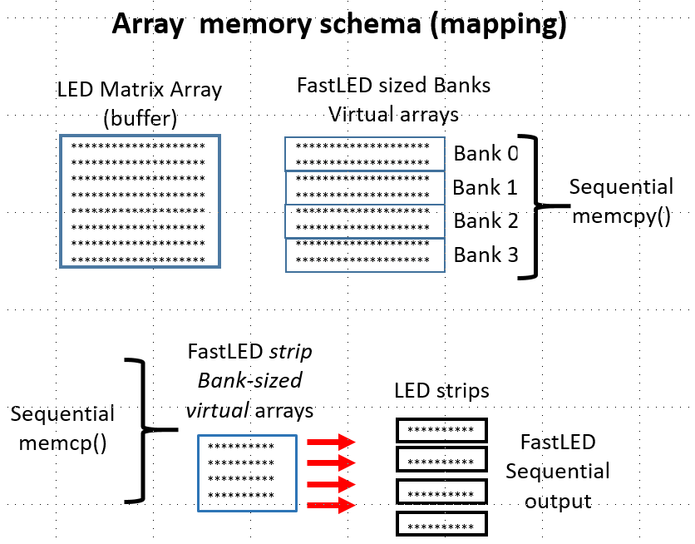

Figure 9 Array memory Schema (mapping)

# Dr Oldies LED Extender

**This Extender is for 2-wire LEDS only. Leds with data and clock lines like the APA102.**

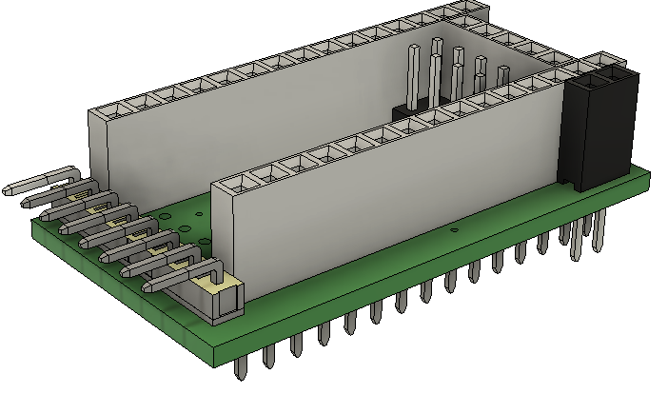This Teensy shield comes in several configurations: 1) stackable and “rotatable” shield for Teensy 3.5 to 4.1 (4.0 or 4.1 recommended), and 2) stand-alone PCB for other processor boards.

Each design above also has a: 3) 1-wire LED and 4) 2-wire LED pin configuration. 32 bit MCUs are recommended for non-shield versions. * bit MCUs don’t have the speed or memory for large LED matrix applications.

**Stacking:**

Figure 10 LED Extender Teensy Shield. The teensy can be mounted in two directions for two pin configurations.

Boards come with long-tale stacking header pins to pass-thru all pins including pins not used by The LED Extender.

In setup() CALL leds.ExtInit() function to initialize the FastLED Banks controllers.

leds.ExtInit(NUM_LEDS, NUM_BANKS, NUM_STRIPS, BRIGHTNESS);

**Configurations: for ordering:**

LED Extender for 1-wire LED strips

V1.0-Shield_1W - Shield for Teensy 3.5 – 4.1 (4.0 or 4.1 recommended)

V1.0-NON_1W - Non-shield version recommend for 32 bit MCUs

LED Extender V1.0-2 for 2-wire wire LED strips

V1.0-Shield_2W - Shield for Teensy 3.5 – 4.1 (4.0 or 4.1 recommended)

V1.0-NON_2W - Non-shield version recommend for 32 bit MCUs

## Understanding the LED Extender, multiplexing, and limitations of serial strip LEDs

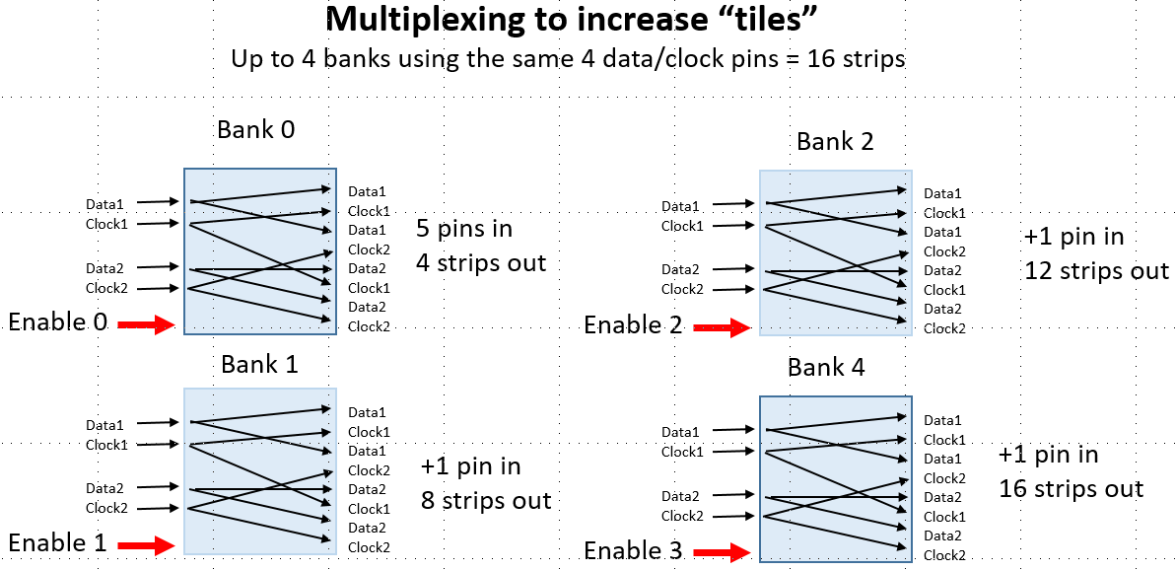

Figure 8 Multiplexing to increase tiles

## LED Extender Enabled Functions

Using the LED Extenders for control of more led strip segments is integrated seamlessly into LEDMatrix_22 once the Extender is initialized with leds.EXTInit().

|  |  |
| --- | --- |
| **New to LEDMatrix_22** | **Comments** |
| ExtInit(numLeds,  numBanks,  numStrips,  brightness); | Initialize to the number and sizes of strips and Extender banks. Setting the global brightness. |
| LEDShow(); | Refresh entire matrix, including all banks and strips |
| LEDShow(gBrightness) | Show with a new brightness |
|  |  |
| **Display individual Banks** |  |
| LEDShow( Bank,  gBrightness); | Show/refresh/display a individual bank (i.e. segmented portions of the matrix panel and the attached led strips). |
| LEDShow( Bank1,  Bank2,  gBrightness); | Any two Banks |
| LEDShow( Bank1,  Bank2,  Bank3,  gBrightness); | Any 3 Banks |

## Array Memory Use

Instead of one large led array, to use strips and Banks we must use these Controllers - one per led strip BUT for my Banks, the "output" array is only part of the full led array. For a 1024 led array with 4 Banks, each is only 256 leds in 4 strips. Further, for 4 strips in each bank we now have 64 leds in each strip and 4 controllers as below.

Finally, each BANK is using the same 4 pins and the SAME 256 LED array. memcpy copies the 256 led portion of the fill array into this 256 led output array, once for each Bank.

## 

## Section 3a: #define HAS_EXTENDER

If you are not using the LED Extender Shields, ignore this section and the header definitions. Set HAS_EXTENDER false, or use an example configuration_22.h without this section.

**Comments**

To use the LED Extender shields, set this to true.

1 to 4 extender shields

1 to 14 led strips per shield. These “strips” can be connections into a large matrix panel



Figure 5 Section 3a: #define HAS_EXTENDER

## Section 3b: LED Extender pin definitions in the Extender section

The LED Shield can be connected to the Teensy (any 3.2 to 4.1) in two directions. If Teensy pins are needed for other operations or controls the Extender interferes with, hopefully, rotating the shield will free up the needed pins.

Here is a list of the pin combinations. See the LED Extender Shield documentation for more details.

Figure 6 Section 3b: LED Extender pin definitions in the Extender section



**Bank enable pins:**

Configuration 1

Configuration 2

**Data/Clock pins:**

Configuration 1

Configuration 2

## Understanding the configuration header sections in combination

When you add or remove the tiles/Blocks and the Extender functionality, the initialization calls for LEDMatrix/FastLED changes. To avoid compile errors, use the following comments.

|  |  |  |
| --- | --- | --- |
| **Enabling/disabling** | **Example Sketches** | **Configuration_22.h settings** |
| #define HAS_BLOCKS  false  #define HAS_EXTENDER  false |  | Simple led array with one continuous led strip.  No tiling or Extender Bank routines available.  MATRIX_TILE_HEIGHT, MATRIX_TILE_WIDTH and related variables are not defined.    Initialize array with:  *cLEDMatrix<MATRIX_WIDTH_DIR, MATRIX_HEIGHT_DIR, MATRIX_TYPE> leds;*  Must comment out:  *leds.ExtInit(NUM_LEDS, NUM_BANKS, NUM_STRIPS, BRIGHTNESS);* |
| #define HAS_BLOCKS  true  #define HAS_EXTENDER false |  | Complex arrays with Blocks/tiling sub-configurations.  Array is made up of one continuous led strip.    Initialize array with:  *cLEDMatrix<MATRIX_TILE_WIDTH, MATRIX_TILE_HEIGHT, LEDS_IN_TILE, MATRIX_TILE_H_DIR, MATRIX_TILE_V_DIR, TILES_IN_MATRIX> leds;*  Must comment out:  *leds.ExtInit(NUM_LEDS, NUM_BANKS, NUM_STRIPS, BRIGHTNESS);* |
| #define HAS_BLOCKS  false  #define HAS_EXTENDER  true |  | Simple led array without tiles and zigzaging.  Led array can be cut into multiple led strips (maximum 16). Using the LED Extender to connect strips.    Initialize array with:  *cLEDMatrix<MATRIX_WIDTH_DIR, MATRIX_HEIGHT_DIR, MATRIX_TYPE> leds;*  Add ExtInit() to setup():  *leds.ExtInit(NUM_LEDS, NUM_BANKS, NUM_STRIPS, BRIGHTNESS);* |
| #define HAS_BLOCKS  true  #define HAS_EXTENDER  true |  | Complex arrays with Blocks/tiling sub-configurations.  Led array can be cut into multiple led strips (maximum 16). Using the LED Extender to connect strips.    Initialize array with:  *cLEDMatrix<MATRIX_TILE_WIDTH, MATRIX_TILE_HEIGHT, LEDS_IN_TILE, MATRIX_TILE_H_DIR, MATRIX_TILE_V_DIR, TILES_IN_MATRIX> leds;*  Add ExtInit() to setup():  *leds.ExtInit(NUM_LEDS, NUM_BANKS, NUM_STRIPS, BRIGHTNESS);* |

# Errors and Possible Fixes

Sparkles and pattern breakup (Dotstar and APA102)

Data transmission for 2-wire leds fails if strips are “too long.” Depending on your setup, this may be after 255, 144, or only 50 leds. Possible solutions:

**First – Be sure your GROUND is connected to the MCU, LED strips, and the power supply solidly!**

* The best solution is to use my LED Extender shields to break down the array into multiple sets.
* Use heavier data/clock wires (many Dupont jumpers wires are only 26 awg.)
* Use heavier power lines and “inject” addition power along the strips.

Dimming at far end of strip

* Use heavier power lines and “inject” addition power along the strips.

## Redefined PROGMEM Error

This occurs as more fonts or bitmaps are included into LEDMatrix_22. For example glcdfont.c does this.

*#ifdef __AVR__*

*#include <avr/io.h>*

*#include <avr/pgmspace.h>*

*#elif defined(ESP8266)*

*#include <pgmspace.h>*

*#else*

*#ifdef PROGMEM              //remove redefinition warning*

*#undef PROGMEM*

*#endif*

*#define PROGMEM*

*#endif*

## Report_Generator compile errors

This .cpp may cause compile errors in Visual Studio or VS Code when a new sln or proj is created. Simply REMOVE the .cpp from the editor's file explorer list (without deleting). It's in Source Files.

# List of Functions

All Arrays are Public

In LEDMatrix_22 the led array struct CRGB leds[] should be used for addressing color memory. However, both the FastLED array m_LED[] and the LED Extender strip array are pubic for advanced programming.

*struct CRGB *m_LED;* //LEDMatrix_22 moved to public from protected

*struct CRGB* e_LED;* //Extender output array. Sized to longest LED strip

 cLEDMatrixBase();

virtual uint32_t mXY(uint16_t x, uint16_t y)=0;

void SetLEDArray(struct CRGB *pLED);  // Only used with externally defined LED arrays

struct CRGB *operator[](int n);

struct CRGB &operator()(int16_t x, int16_t y);

struct CRGB &operator()(int16_t i);

int Size()  { return(m_WH); }

int Width() { return(m_Width);  }

int Height()  { return(m_Height); }

void HorizontalMirror(bool FullHeight = true);

void VerticalMirror();

void QuadrantMirror();

void QuadrantRotateMirror();

void TriangleTopMirror(bool FullHeight = true);

void TriangleBottomMirror(bool FullHeight = true);

void QuadrantTopTriangleMirror();

void QuadrantBottomTriangleMirror();

void drawPixel(int16_t x, int16_t y, CRGB Col);

void drawLine(int16_t x0, int16_t y0, int16_t x1, int16_t y1, CRGB Col);

void drawRectangle(int16_t x0, int16_t y0, int16_t x1, int16_t y1, CRGB Col);

void drawCircle(int16_t xc, int16_t yc, uint16_t r, CRGB Col);

void drawFilledRectangle(int16_t x0, int16_t y0, int16_t x1, int16_t y1, CRGB Col);

void drawFilledCircle(int16_t xc, int16_t yc, uint16_t r, CRGB Col);

//================LEDMatrix_22 additions ============================

CRGB getPixel(int16_t x, int16_t y);

void fadeAll(uint16_t value);

void fillScreen(CRGB color);

void drawTriangle(int16_t x0, int16_t y0, int16_t x1, int16_t y1, int16_t x2, int16_t y2, CRGB color);

void drawFastVLine(int16_t x, int16_t y, int16_t h, CRGB color);

void drawFastHLine(int16_t x, int16_t y, int16_t w, CRGB color);

void drawFilledTriangle(int16_t x0, int16_t y0, int16_t x1, int16_t y1, int16_t x2, int16_t y2, CRGB color);

void drawCircleHelper(int16_t x0, int16_t y0, int16_t r, uint8_t cornername, CRGB color);

void drawFillCircleHelper(int16_t x0, int16_t y0, int16_t r, uint8_t cornername, int16_t delta, CRGB color);

void drawRoundRect(int16_t x, int16_t y, int16_t w, int16_t h, int16_t r, CRGB color);

void drawFillRoundRect(int16_t x, int16_t y, int16_t w, int16_t h, int16_t r, CRGB color);

void clear();

void showColor(CRGB color);

void setBrightness(uint8_t bght);

   // ----------------text---------------------------

void setCursor(int16_t x, int16_t y);

void setTextColor(CRGB c);

void setTextColor(CRGB c, CRGB bg);

void setTextSize(uint8_t s);

void setTextWrap(boolean w);

void setRotation(uint8_t r);

void cp437(boolean x=true);

void setFont(const GFXfont *f = NULL);

int16_t getCursorX(void) const;      // get current cursor position (get rotation safe maximum values)

int16_t getCursorY(void) const;

uint8_t getRotation(void) const;

void getTextBounds(char *string, int16_t x, int16_t y, int16_t *x1, int16_t *y1, uint16_t *w, uint16_t *h);

void getTextBounds(const __FlashStringHelper *s, int16_t x, int16_t y, int16_t *x1, int16_t *y1, uint16_t *w, uint16_t *h);

void drawChar(int16_t x, int16_t y, unsigned char c, CRGB color, CRGB bg, uint8_t size);

void write(char);

void print(char text[]);

void invertDisplay();

void invertSquare(int16_t x0, int16_t y0, int16_t x1, int16_t y1);

  //-----------------------------bitmaps ----------------------------------

void drawBitmap(int16_t x, int16_t y, const uint8_t * bitmapName, int16_t w, int16_t h, CRGB color);

void drawBitmap(int16_t x, int16_t y, const uint8_t * bitmapName, int16_t w, int16_t h, CRGB color, CRGB bg);

void drawBitmap(int16_t x, int16_t y, uint8_t* bitmapName, int16_t w, int16_t h, CRGB color);

void drawBitmap(int16_t x, int16_t y, uint8_t* bitmapName, int16_t w, int16_t h, CRGB color, CRGB bg);

void drawXBitmap(int16_t x, int16_t y, const uint8_t* bitmapName, int16_t w, int16_t h, CRGB color);

//================LEDMatrix_22 additions - 24 bit full color bitmaps ============================

void _bitmapZigzag(int16_t x, int16_t y, uint8_t i,  uint8_t j, int16_t w, boolean zigzag, CRGB col);

void drawBitmap24(int16_t x, int16_t y, const long* bitmapName, int16_t w, int16_t h, boolean progMem, boolean zigzag, CRGB bg);

void drawBitmap24(int16_t x, int16_t y, const long* bitmapName, int16_t w, int16_t h, CRGB bg);

 //================LEDMatrix_22 additions - 24 bit full color sprites ============================

void spriteInit(uint8_t spriteNum, int16_t w, int16_t h, const long* bitmapName, boolean progMem, boolean zigzag);

void drawSprite(uint8_t spriteNum, int16_t x, int16_t y, CRGB bg);

void eraseSprite(uint8_t spriteNum, int16_t x1, int16_t y1, CRGB bg);

//================LEDMatrix_22 additions - 24 bit full color screen block save-restore ==========

boolean blockInit(uint8_t blockNum, uint8_t w, uint8_t h);

boolean blockStore(uint8_t blockNum, int16_t x1, int16_t y1);

void blockRestore(uint8_t blockNum, int16_t x1, int16_t y1);

void blockRestore(uint8_t blockNum);

void freeBlock(uint8_t blockNum);

//=====================LEDMatrix_22  EXTENDER hardware ===============================

void LEDShow();

void LEDShow(uint8_t gBrightness);

void LEDShow(uint8_t Bank, uint8_t gBrightness);

void LEDShow(uint8_t Bank1, uint8_t Bank2, uint8_t gBrightness);

void LEDShow(uint8_t Bank1, uint8_t Bank2, uint8_t Bank3, uint8_t gBrightness);

void ExtInit(uint16_t numLeds, uint8_t numBanks, uint8_t numStrips, uint8_t brightness);

void defineBanks();

# FastLED function list (partial)

These Fast_LED are relevant to the LEDMatrix_22 library and can add additional led control to your sketches.

|  |  |
| --- | --- |
| FastLED.h |  |
| **void setBrightness(uint8_t scale)** | Set the global brightness scaling  @param scale a 0-255 value for how much to scale all leds before writing them out |
| **uint8_t getBrightness()** | Get the current global brightness setting  @returns the current global brightness value |
| **inline void setMaxPowerInVoltsAndMilliamps(uint8_t volts, uint32_t milliamps)** | Set the maximum power to be used, given in volts and milliamps.  @param volts - how many volts the leds are being driven at (usually 5)  @param milliamps - the maximum milliamps of power draw you want |
| **inline void setMaxPowerInMilliWatts(uint32_t milliwatts)** | Set the maximum power to be used, given in milliwatts  @param milliwatts - the max power draw desired, in milliwatts |
| **void show(uint8_t scale);** | Update all our controllers with the current led colors, using the passed in brightness  @param scale temporarily override the scale |
| **void show() { show(m_Scale); }** | Update all our controllers with the current led colors |
| **void clear(bool writeData = false);** | clear the leds, wiping the local array of data, optionally black out the leds as well  @param writeData whether or not to write out to the leds as well |
| **void clearData();** | clear out the local data array |
| **void showColor(const struct CRGB & color, uint8_t scale);** | Set all leds on all controllers to the given color/scale  @param color what color to set the leds to  @param scale what brightness scale to show at |
| **void showColor(const struct CRGB & color)** | Set all leds on all controllers to the given color  @param color what color to set the leds to |
| **void delay(unsigned long ms);** | Delay for the given number of milliseconds. Provided to allow the library to be used on platforms that don't have a delay function (to allow code to be more portable). Note: this will call show constantly to drive the dithering engine (and will call show at least once).  @param ms the number of milliseconds to pause for |
| **void setTemperature(const struct CRGB & temp);** | Set a global color temperature. Sets the color temperature for all added led strips, overriding whatever previous color temperature those controllers may have had  @param temp A CRGB structure describing the color temperature |
| **void setCorrection(const struct CRGB & correction);** | Set a global color correction. Sets the color correction for all added led strips, overriding whatever previous color correction those controllers may have had.  @param correction A CRGB structure describin the color correction. |
| **void setDither(uint8_t ditherMode = BINARY_DITHER);** | Set the dithering mode. Sets the dithering mode for all added led strips, overriding whatever previous dithering option those controllers may have had.  @param ditherMode - what type of dithering to use, either BINARY_DITHER or DISABLE_DITHER |
| **void setMaxRefreshRate(uint16_t refresh, bool constrain=false);** | Set the maximum refresh rate. This is global for all leds. Attempts to call show faster than this rate will simply wait. Note that the refresh rate defaults to the slowest refresh rate of all the leds added through addLeds. If you wish to set/override this rate, be sure to call setMaxRefreshRate _after_ adding all of your leds.  @param refresh - maximum refresh rate in hz  @param constrain - constrain refresh rate to the slowest speed yet set |
| **void countFPS(int nFrames=25);** | for debugging, will keep track of time between calls to count FPS, and every nFrames calls, it will update an internal counter for the current FPS.  @todo make this a rolling counter  @param nFrames - how many frames to time for determining FPS |
| **uint16_t getFPS()** | Get the number of frames/second being written out  @returns the most recently computed FPS value |
| **int count();** | Get how many controllers have been registered  @returns the number of controllers (strips) that have been added with addLeds |
| **CLEDController & operator[](int x);** | Get a reference to a registered controller  @returns a reference to the Nth controller |
| **int size()** | Get the number of leds in the first controller  @returns the number of LEDs in the first controller |
| **CRGB *leds()** | Get a pointer to led data for the first controller  @returns pointer to the CRGB buffer for the first controller |
| Controller.h |  |
| **CLEDController() : m_Data(NULL), m_ColorCorrection(UncorrectedColor), m_ColorTemperature(UncorrectedTemperature), m_DitherMode(BINARY_DITHER), m_nLeds(0)** | create an led controller object, add it to the chain of controllers |
| **virtual void init() = 0;** | initialize the LED controller |
| **virtual void clearLeds(int nLeds)** | Clear out/zero out the given number of leds. |
| **void show(const struct CRGB *data, int nLeds, uint8_t brightness)** | show function w/integer brightness, will scale for color correction and temperature |
| **void showColor(const struct CRGB &data, int nLeds, uint8_t brightness)** | show function w/integer brightness, will scale for color correction and temperature |
| **void showLeds(uint8_t brightness=255** | show function using the "attached to this controller" led data |
| **void showColor(const struct CRGB & data, uint8_t brightness=255)** | show the given color on the led strip |
| **static CLEDController *head() { return m_pHead; }** | get the first led controller in the chain of controllers |
| **CLEDController *next() { return m_pNext; }** | get the next controller in the chain after this one. will return NULL at the end of the chain |
| **CLEDController & setLeds(CRGB *data, int nLeds)** | set the default array of leds to be used by this controller |
| **void clearLedData()** | zero out the led data managed by this controller |
| **virtual int size() { return m_nLeds; }** | How many leds does this controller manage? |
| **CRGB* leds() { return m_Data; }** | Pointer to the CRGB array for this controller |
| **CRGB &operator[](int x) { return m_Data[x]; }** | Reference to the n'th item in the controller |

# Multiple LED strips not in a Matrix

LEDStrips_22 is a separate library designed for LED strips not in a matrix panel. This is a “lite” version because the matrix functions have been removes {circle, triangles, bitmaps, etc.). New functions to control individual banks and strips have been added.

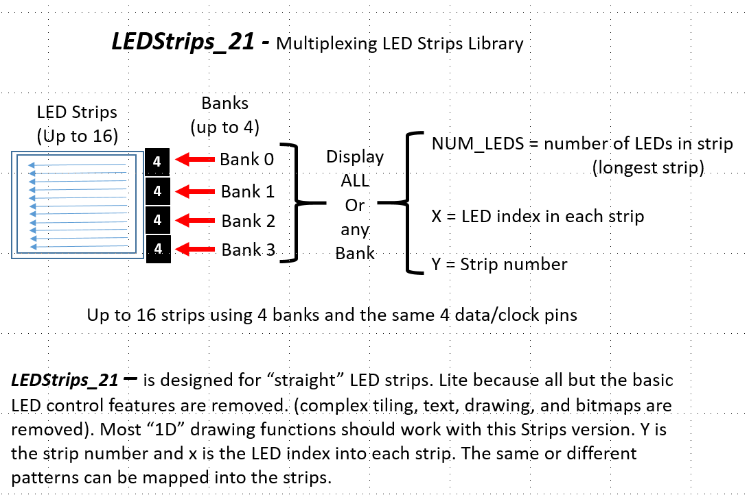

Figure 7 LEDStrips_22 – Multiplexing LED Strips Library

# Examples

In the examples folder there are 3 types of examples

* example XYTable_LookUp files
  + XYTable_LookUp16x16
  + XYTable_LookUp32x32
* example_configuration files
  + 1x144 led strip
  + 8x8_LED_zigzag_Panel
  + 16x16_2x2 tiles_zigzag_NO_extender
  + 32x32_4x4_tiles_zigzag_4x4_extender
  + 32x32_4x4_tiles_zigzag_NO_extender
* examples (Sketches)
  + bitmaps_and_sprite_tests
    - bitmap_test
    - bitmap24_test
    - block_copy
    - sprites_test
  + Cylon_22
  + Cylon_strip
  + Extender test examples
  + flowingRainbow_22
  + fontTest
  + introduction
  + LEDMatrix_22
  + stepThruBasicFunctions
  + Table_Mark_Estes_LEDMatrix_22
  + test_configuration_1st
  + testBrightness2Failure

**fontTest.ino**

//fontTest.ino will run on any size panel

You can use Adafruit_GFX default and custom fonts with LEDMatrix_22. You can dowbload these fonts with the Adafruit library or ither web sites.

Using custom fonts can be confusing. This example shows how to include and use these fonts. One point to note is that AF default fonts x,y is in the upper left of the character. Custom foints x,y is in the lower left. Wrapping does not appear to work with all custom fonts.

cFTest(); //This test creates a structure array to load an use multiple custom fonts.

//fontTest(TomThumb, text); //simple font test with a small font

//textTest(); //These two use the default font

//printTest();

**Introduction.ino**

RUN LEDMatrix_22.ino 1ST TO TEST YOUR LED MATRIX PANEL HARDWARE AND SOFTWARE CONFIGURATION

This sketch introduces you to the numberous functions of this library. Here are the demo functions. These should work regardless of the size of your panel, but some may look odd if the panel is smaller than 16x16.

For 24 bit bitmapping and sprites see the sketches specific to those library functions. Don't try these until you have the basics down.

Scottish_Flag

canvasTest

textTest

invertTest

printTest

StepThru

Cylon

flowingRainbow

**LEDMatrix_22.ino**

Menu driven mapping tests for LEDMatrix_22 library

This sketch allows you to test the mapping of your matrix panel. These menu functions are available through the serial terminal. The general report is printed first so you can review your settings.

If your setting do not include tiling or the extender hardware, these choices will be disabled.

MOST PROBLEMS ARE CAUSED BY IMPROPER SETTINGS OF THE MATRIX PANEL, TILES/BLOCKS. OR EXTENER SETTINGS

Note: TT_numbers_Progmem.h is a small “Tom Thumb” character set file with only numbers to display

MENU tiling and bank sequences.

*Sketch functionality*

Locate and exercise your matrix panel, Extender Banks and Strips.

This is an interactive menu on serial monitor to select functions:

If no blocks, menu stops after 'd'

If no Extender, menu stops after 'e'

a. We will report your configuration.

b. Draw triangles in starting corner and each corner of matrix

IF HAS_BLOCKS

c. Draw arrows in starting corners and centers of tiles

d. Light up each block/tile AND print the number of the Block in sequence

IF HAS_EXTENDER

e. Light up each Bank and number in sequence

f. Light up each strips

g. Display this MENU

**testBrightness2Failure**

APA102, DotStar and similar leds, are sensitive to receving data and passing it along a long strip of leds. The maximum limit is a combination of Brightness, speed (spi_Mhz) and frames per second (fps) for the best balance. Use this sketch to find that balance.

Count the number of brightness levels until your matrix panel leds breakup.

Adjust the speed (Mhz) and frames per second (fps) for the best balance.

**Table_Mark_Estes_22**

Mark Estes' Table code modified (yet again) to work with the LEDMatrix_22 library.

Steps through 113 patterns, and modifies the patterns on following passes.

With this library should be scalable to any size LED matrix panel.

However, not all patterns will be centered in both x and y for non-square panels.

Mods for LEDMatrix_22

Edited the short list to run through more interesting patterns.

Just a few global changes needed for example change class to leds.

Fixed bugs in #8 and #9 that caused lockup

Table.h

Split out variable and functions definitions to this header for clarity

#Pattern control

Via the Arduino serial port, turn off line endings, and use 'n' and 'p' to change patterns

or send '80' to jump to pattern 80 directly.

Table_Mark_Estes (previous version from marc merlin)

Mark Estes' Table code modified to work with just a matrix

Define BESTPATTERNS (Table.h)

Lets you see some of my favorite patterns given that the whole list is otherwise 113 patterns long :)

Video examples (from marc merlin)

* 64x64 with audio: https://photos.app.goo.gl/qLS14Ad6UzCng3Q23

* More 64x64 with audio: https://photos.app.goo.gl/syEPi7O97hgsWKb53

* My 32x24 panel compilation of my favorites patterns: https://www.youtube.com/watch?v=SSllLL5SGCg

Below is a demo of that code running on top of SmartMatrix::GFX:

![image](<https://user-images.githubusercontent.com/1369412/54888844-266bc480-4e5e-11e9-904e-75f417a7d9d2.png>